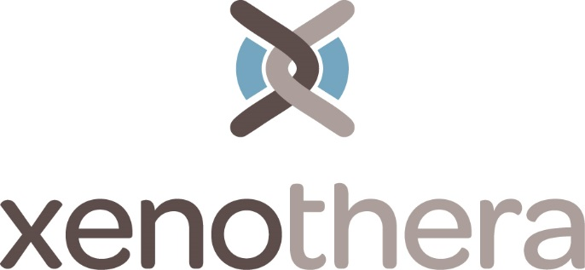

Press Release
Start-up XENOTHERA closes a new capital increase above 2 million euros

Nantes, June 10th 2016.

XENOTHERA, a young biotech who develops an innovative immunosuppressant, has closed on June 2nd, 2016, a second fundraising for more than 2 million euros.
Created by a medical team specialized in organ transplantation and a veterinary world-renowned in animal cloning, XENOTHERA is a young company specialized in immunology and genetic engineering.
After a first fundraising of 810 k€ at the end of 2014, XENOTHERA has reached major achievements in the demonstration of the patient benefits of its lead product (Journal of Clinical Investigation, 2015) and in its pharmaceutical development.
This new fundraising will allow XENOTHERA to finalize the main milestones until the beginning of its clinical trials who will allow the first patients to benefit from its innovation.
The investors are a mix of the original and new partners.
- The initial investors have confirmed their confidence in the project: Pays de la Loire Développement, Business Angels from west of France (ABAB), and private investors
- New investors: STARQUEST 2016, the regional Co-Investment Instrument IDEE, and Business Angels from Arts et Métiers (AMBA)
About XENOTHERA
XENOTHERA is a young start-up from Nantes based at the University of Nantes (Medical School). XENOTHERA develops innovative product in transplantation and other indications (patent from INSERM / University of Nantes / Nantes Hospital)
The team XENOTHERA is managed by Odile DUVAUX, MD, PhD, with a team of world – renowned personalities from medicine, namely the professors Jean-Paul SOULILLOU (University of Nantes) and Jean-Marie BACH (Veterinary School ONIRIS)
XENOTHERA is incubated at Atlanpole and benefits from the support of public funding from the French Investment Bank (BPI) and the region Pays de la Loire. XENOTHERA was regional laureate at the award Creation Development from the French Research Ministry in 2014.
About Pays de la Loire Développement (Sodéro Gestion)
The mission of Pays de la Loire Développement (Sodéro Gestion) is to finance regional companies with less than 4M€ turnover in equity. Its capital share is usually from 5 to 30%; the investments cover small traditional companies and seed / creation projects with high technological value.
About ABAB
ABAB is a network of private investors created in 2007 by Mr. Estival for the label of Nantes Altantic Financial Center. It is hosted and supported by both the Chamber of Commerce of Nantes Saint-Nazaire and the Chamber of Commerce of Maine-et-Loire and surroundings. The network gathers approximately 100 seasoned entrepreneurs with successful experience.
About AMBA
Arts & Métiers Business Angels is the network of alumni from Arts et Métiers Paris Tech, who want to invest in innovative companies and support project holders in the starting phase by bringing their experience and technical expertise.
About STARQUEST
STARQUEST is a venture capital fund that invests in companies with high technological value in the first years following their creation. STARQUEST has become in a few years the second operator in France in this segment, with more than 30 participations per year. STARQUEST defines itself as “entrepreneurs in capital”, which ambition is to help entrepreneurs accelerate their growth by bringing high value beyond the invested funds.
About IDEE
IDEE is the co-investment venture fund from the Region Pays de la Loire administered by Siparex. The mission of IDEE is to mobilize actors and resources from the Region in order to boost the territorial development. Through association with financial actors, the Region supports innovative initiative which feed the regional valorization, and encourages regional companies towards success. This is all in a perspective of sustainable and long-term development. The beneficiaries are companies having their headquarters in the region, or at least a clear impact on local employment.

Contact : Dr Odile DUVAUX, CEO - odile.duvaux@xenothera.com - +33 612192724

