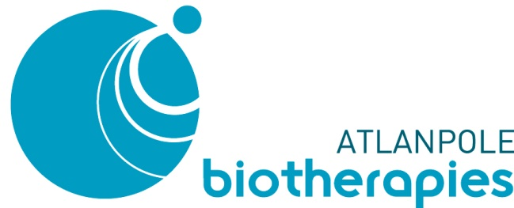

Press Release 20 February 2018

Atlanpole Biotherapies presents its strategic priorities for developing the medicine of tomorrow

At its annual meeting today, the Atlanpole Biotherapies competitiveness cluster presented its 2017 business report and outlook for 2018. While the cluster’s primary areas of focus since its foundation—immunotherapy, regenerative medicine, and radiopharmaceuticals, all relying on scientific excellence at an international scale—remain central, the multidisciplinary fields of e-health and P4 medicine are new strategic issues for 2018.
More than a hundred companies at the cutting edge of advanced therapies, the fruit of this scientific excellence, are members of the cluster. They collectively represent over 2,000 jobs of very high added value—accounting for 20% of all French biotech/health jobs.
Through their innovations, these companies are making our region stand out nationally and internationally. They are inventing the medicine of tomorrow.

- Nantes, a bastion of biotherapies
Our country has all the advantages it needs to become a champion of advanced therapies, including cell therapy, gene therapy, immunotherapy, and organ transplants.
To address the theme of bioproduction, the cluster—ideally positioned on the map of dedicated sites in France—has today welcomed a LEEM representative to present a study entitled ‘Bioproduction: An opportunity for France to seize?’
Atlanpole’s constituent territory—Brittany, Pays de la Loire, and Centre Val de Loire—is home to firms that are specialists in this field. Though biotech companies already know how to produce small volumes of biologics (e.g. antibodies, cells, and therapeutic vectors), their challenge is ramping up to large-scale production.
This is precisely the area of expertise developed by the following Atlanpole member firms:
- Valneva—directed by Franck Grimaud and specialized in vaccine production, a pioneer in the field
- Clean Cells—producer of cell batches and, since 2014, an ANSM-approved pharmaceutical establishment
- Horama—gene therapy specialist that started clinical batch production in 2017

- Atlanpole players are pioneers in P4 medicine

Towards preventive, personalized, predictive, and participative (P4) medicine
Until now, the same treatment was offered to all patients suffering from the same disease. Today, treatments can be adapted to each patient. And tomorrow, the entire patient environment will be taken into account. It will be possible to predict not only how likely patients will develop a given disease (Prediction), but also how well they will respond to target treatments (Personalization). And there will be the possibility of taking corrective and preventive measures before certain conditions can develop or to limit their recurrence after treatment (Prevention). Finally, this new approach promotes effective dialogue between all parties involved in the healthcare process—including patients, healthcare professionals, families, patients’ associations, psychologists, and regulatory agencies—to ensure optimal patient care, help society embrace new healthcare technology, and guarantee the sustainability of the health insurance system (Participation). Digital technology riding the wave of Big Data and connected objects is a major pillar of P4 medicine.

It optimizes treatment efficacy, enhancing patients’ quality of life and the work of their physicians. A cohort of Atlanpole members that have blazed a trail in taking the complete patient environment into account are mapping out the cluster’s strategy in this domain.
The scientific excellence fostered at Biofortis, under the direction of Murielle Cazaubiel, led Mérieux NutriSciences to acquire the firm in 2009. It is now pursuing its growth in Nantes. Such advanced expertise is also being developed at Nantes Hospital’s GI disease institute—the Institut des Maladies de l’Appareil Digestif (IMAD)—a centre for medical care, research, and education specialized in illnesses of the liver and digestive tract.

Focus on some of our member companies:

Date founded: 06 May 1999
At the forefront of innovation, this biotech firm is dedicated to the development, production, and marketing of innovative vaccines.
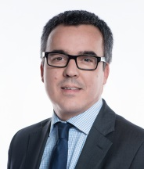
What’s new? With a turnover of €109.8 million and 12% growth in 2017, Valneva SE is announcing a USD 39.6 million contract with the US Department of Defence for the supply of its IXIARO® vaccine against Japanese encephalitis.

Franck Grimaud
President and CEO,
Chairman of the Board

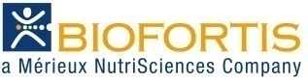
Date founded: 01 January 2002
Biofortis is the global research arm of Mérieux NutriSciences, furthering innovation in food, nutrition, healthcare, cosmetics, and consumer goods.
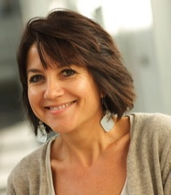

What’s new? The Mérieux Foundation, with the backing of Mérieux NutriSciences, an Institut Mérieux company dedicated to protecting consumer health, invites you to attend the sixth edition of Better Foods for Better Health, running from 20 to 22 March 2018.

Murielle Cazaubiel
Former President of Atlanpole Biotherapies and Managing Director of Mérieux NutriSciences

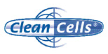
Date founded: 31 July 2000
Vendée-based Clean Cells is an ANSM-accredited pharmaceutical establishment specialized in the viral and biological security of biological medicines, the production and secure storage of GMP-grade cell and virus banks, and the manufacture of experimental biologics like cell therapy products.

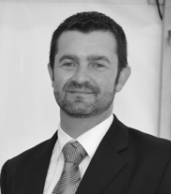
What’s new? In partnership with other cluster members, Clean Cell is launching the innovative HybridADCC project, under the aegis of Atlanpole Biotherapies. Its objective is to identify new antibodies and therapeutic targets through a unique method for analysing mouse antibody ADCC activity in a human cell model. The French Fonds Unique Interministériel (FUI) fund is providing backing to the tune of €2.4 million—co-financed by Bpifrance and the Pays de la Loire regional government—over 36 months.

Olivier Boisteau
President and co-founder of Clean Cells; Vice President of Atlanpole Biotherapies

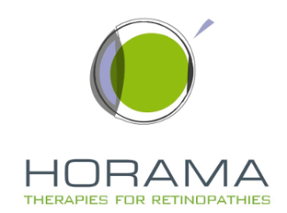

Date founded: 10 March 2014
Horama is a French biotech firm based in Paris and Nantes that is specialized in gene therapy for the treatment of rare genetic eye diseases.

What’s new? Horama announced that it raised €19-million in Series B funds from four new backers— Kurma Partners, Fund+, Pontifax, and Idinvest—in addition to its traditional investors, Omnes Capital, GO Capital, and Sham Innovation Santé/Turenne.
The main goal of this funding operation is to finance the development of the HORAPDE6B project, and specifically its entry into the clinical phase, just authorized by the French National Agency for Medicines and Health Products
(ANSM).

Christine Placet
CEO of Horama

___________________________________

Key figures for the Atlanpole Biotherapies network:

- members, including:
- 120 biotech/health firms, creating over 2,000 jobs
- 56 research laboratories
- 5 institutes involved in basic and clinical research in the fields of organ transplants, oncology, cardiovascular and GI diseases, and respiratory health
- 41 technical hubs
- 2 hospitals (in Nantes and Angers)
- 5 universities (in Nantes, Angers, Tours, Poitiers, Rennes, and Brest)
- Institute of Cancer Research in Western France (ICO), Nantes/Angers
- ARRONAX, a high-energy cyclotron that is unique in Europe
- Oniris National College of Veterinary Medicine, Food Science, and Engineering
- Audencia Business School, specialized in international management

Noteworthy events in 2017:

  - Horama raised nearly €19 million in funds for development of the HORAPDE6B project
  - Hemarina, winner of the Deloitte Technology Fast 50 Future Biotech Firm Award, announces it has raised €8 million in funding.
  - The project driven by Clean Cells is to receive 36 months of FUI financing to cover a total cost of €2.4 million.
  - The University of Nantes, the Centrale Nantes school of engineering, Nantes Hospital, and the French National Institute of Health and Medical Research (INSERM) have submitted their bid in response an extremely selective national call for tenders. The stated aim of their project, dubbed NExT, is to ‘substantially consolidate two pivotal areas of research: the healthcare of tomorrow and the industry of the future’.

Atlanpole Biotherapies in brief:

Atlanpole Biotherapies is a French interregional competitiveness cluster representing Pays de la Loire, Brittany, and Centre–Val de Loire and accredited by the French Ministry of Industry (July 2005). It pools the expertise of laboratories, technical hubs, and firms to create a targeted, comprehensive, and competitive public-private network spanning the value chain for biologics, from the discovery of drug targets to clinical evaluation.
The cluster is helping to construct the medicine of tomorrow along four avenues of development:
- immunotherapy
- radiopharmaceuticals
- regenerative medicine
- innovative technologies for biotherapies

